Schedule Management Plan

*Villamin Wood and Iron Works System*

Villamin Wood and Iron Works

G367+F29, MRT Ave

Taguig, 1632

April 2023

**Table of Contents**

Introduction 2

Schedule Management Approach 2

Schedule Control 3

Schedule Changes and Thresholds 3

Scope Change 3

Appendices 3

Sponsor Acceptance 7

# 6.4. Schedule Management Plan

# 6.4.1. Introduction

The schedule management plan is a roadmap for the process of executing the project. This is important as they provide the status of the project to the project team, sponsor, and stakeholders. The purpose of the schedule management plan is to specify the methodology the project team will employ in putting together the project schedule. The schedule management plan must be identified, analyzed, documented, prioritized, approved, or rejected, and published. This plan will help the team to monitor the progress of the project and manage the changes to the project schedule after being approved.

# 6.4.2. Schedule Management Approach

The schedule management plan will be created with the help of the deliverables in the Work Breakdown Structure (WBS). The specific work packages that must be carried out to complete each deliverable will be identified by the activity definition. To determine the order of work packages, an activity sequencing will be used and assigned between project activities. The number of work periods necessary to finish work packages will be determined using activity duration estimation. To finish schedule development, resource estimating will be used to allocate resources to work packages.

Once an initial schedule has been done, the project team and stakeholders will review the task and must agree on the proposed work package assignments, duration, and schedule. Afterwards, the project team will have it reviewed by the project sponsor for the approval and have the schedule baselined.

The milestones for the projects schedule are as follows:

* Completion of deliverables
* Completion of scope management plan and Work Breakdown Structure (WBS)
* Approval of initial schedule baseline
* Project Sponsor budget approval
* Roles and responsibilities approval
* Acceptance of deliverables

Schedule development roles and responsibilities are the following:

**Project Manager –** responsible for facilitating and checking the progress of the deliverables. The project manager also supports the team, stakeholder, and project sponsor on validating the proposed schedule.

**Project Team –** responsible for working and completing the deliverables. The project team is also responsible for reviewing the proposed schedule and assigning activities after the schedule’s approval.

**Project Stakeholders –** responsible for reviewing of proposed schedule and assisting in approvals.

**Project Sponsor -** responsible for reviewing of proposed schedule and approval of the final schedule before baselined.

# 6.4.3. Schedule Control

The project schedule will be reviewed and updated on a twice a week basis with actual start, actual initial completion, and the final completion percentage which will be given and reviewed by the Project Manager. Additionally, the project manager will be responsible for holding meetings for the updates and reviews, submission of schedule change requests, and reports of the schedule status according to the project’s communication plan.

The project team will be responsible for participating in the meetings for updates and reviews, reporting any changes of actual start and actual initial completion to the project manager.

The project sponsor will be responsible for maintaining the acknowledgement of the project schedule status, review and approve any schedule change requests that will be submitted by the project manager.

# 6.4.4. Schedule Changes and Thresholds

If there’s a need for a change in the schedule, the team must hold a meeting with the project manager and identify the proposed changes as they will affect the tasks in progress. While holding the meeting, the team must identify the cause of change and other changes and find a way of taking an alternative action to use for the success of the proposed scheduled plan. Afterwards, the project manager may review the proposed changes and submit the schedule change request form to the project stakeholders and project sponsor.

# 6.4.5. Scope Change

The project team will need to assess the impact of any changes to the project scope that have been approved by the project sponsor on the current schedule. The project manager may request that the schedule be re-baselined to consider any changes that must be made as part of the new project scope if it is determined that the scope change will significantly affect the current project schedule. This request must be reviewed and approved by the project sponsor before the schedule can be re-baselined.

# Appendices

Initial Schedule Baseline:

Schedule Change Request Form:

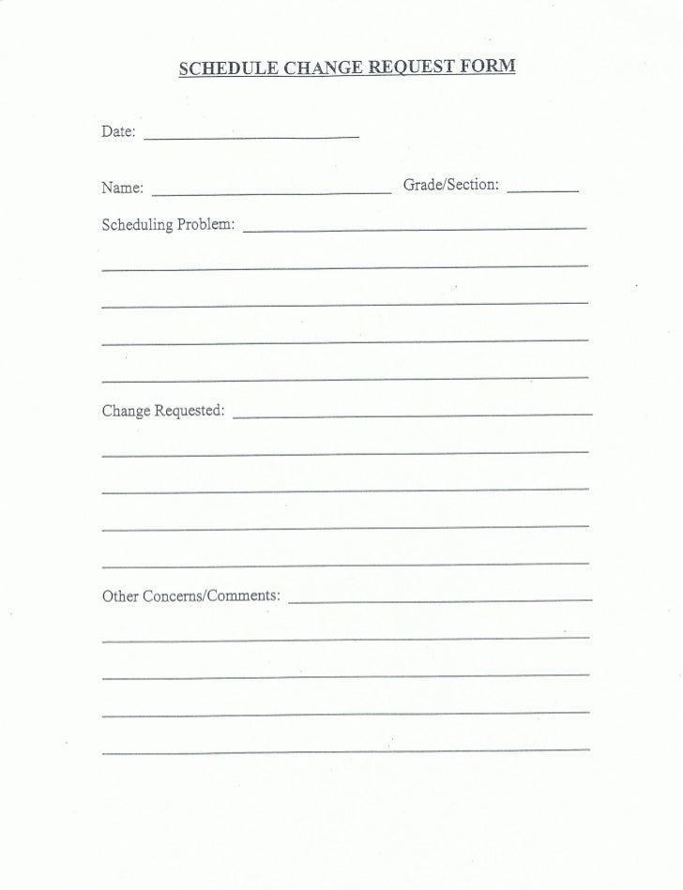

# Sponsor Acceptance

Approved by the Project Sponsor:

Date:

<Project Sponsor>

<Project Sponsor Title>